Art 305 Lesson Plan
Group Members: | Claudia Serrano and  Will Tran
Lesson Title: | The Aesthetic Experience
Grade Level: | 12th | Length of Lesson: | 1 Week
Brief Description: | The students will use the app Color Effects and take a picture that causes them to reflect on everyday issues. They will present their image, speak about their experience, and submit a one page reflection.
State Standards: | Content Standard 1 – 1.4 Analyze and describe how the composition of a work of art is affected by the use of a particular principle of design.  Content Standard 2 – 2.3 Develop and refine skill in the manipulation of digital imagery (either still or video).  Content Standard 3 – 3.2 Identify and describe the role and influence of new technologies on contemporary works of art.  Content Standard 4 – 4.1 Articulate how personal beliefs, cultural traditions, and current social, economic, and political contexts influence the interpretation of the meaning or message in a work of art.  Content Standard 5 – 5.2 Create a work of art that communicates a cross-cultural or universal theme taken from literature or history.
Common Core  Standard: | Common Core Standard - 4 Determine the meaning of images as they are used, including analyzing how the artist uses and refines meaning of a key component.
Big Question: | How are everyday issues available to you on a daily basis?
Objectives | Students will identify various issues that plague our society and use the app Color Effects to produce a work of art and reflection.
Art History: | Graffiti anonymous artist, Banksy, traditionally incorporates monochromatic imagery, with highlighted components into his art. Banksy art is known for having social issues depicted and a wide range of translations accompanied. Color Effects app will allow the students to achieve this same type of look through photography. Banksy is able to give many different meanings with a single image, and it is up to the viewer to translate the meaning. Likewise, a person can see the same image and have interpretations. By highlighting the component that emphasizes societal issues, the user can more easily showcase it to the audience, which allows for interpretation.
Major Themes: | Issues in our everyday lives.
Elements/  Principles: | Emphasis, value, and contrast. | Vocabulary: | Political imagery, social issues
Materials needed: | Phone Camera, app, paper, pencil/pen
Anticipatory Set | A before and after image of the project. How does the image change when you highlight just one aspect?
Teaching Strategies |  | Student Activities
Day 1. Anticipatory Set, Lecture and examples |  | Day 1. Taking Notes, asking questions, and brainstorming.
Day 2. Review the assignment, present the App, and do a tutorial. |  | Day 2. Follow along with tutorial, ask questions, find an issue within the classroom.
Day 3. Review and ask any volunteers about daily issues they found in class and give them feedback. Explain that the students will now go outside and find daily issues. ex: not enough tables |  | Day 3. The students can ask any questions about the assignment. Then any students who want to show their image can present it. Students can give feedback. Towards the end half of the class all the students will go outside and find everyday struggles or issues within their school.
Day 4. Explain the final step of the assignment. The students will now work individually. They will come up with their own image of daily social issues. Provide a rubric for evaluation and for the writing assignment. Give an example of what the presentation will consist of and have them present the next day. |  | Day 4. Students will have their second image from the previous day. They will takes notes and ask questions about the final step. Begin to brainstorm on what types of daily issues they encounter. Begin to work on their Color Effects app for the final presentation on day 5.
Day 5. Explain to the students they will give feedback and engage in a class critique. The teacher will hand out small scraps of paper to the students so that they can provide a one word feeling of what they experience when they see their peers presentation. |  | Day 5. Students will engage in discussion and class critique. They will take the scraps of paper and give their peer a one word feeling of what their peers image makes them feel. The students will give these papers to the presenter at the end of the presentation.
Assessment plan: | The students will be given a rubric for both the image component, the written reflection, and the power point.  -The image must be done on the Effects app.  -The image must be original.  -The image must have a highlighted component.  -Students must be able to explain their social issue verbally and on paper.  - The image is worth 40 points.  - The reflection is worth 30 points.  - The presentation of final image is worth 30 points.
Closure: | Students will answer the “Big Question” in an informal assessment (verbal). They will submit their image and reflection.
Social Issue: | The social issue that we are conveying with our lesson plan can consist of emotional turmoil, daily issues in life, or social issues they have witnessed or experienced. Students struggle with various forms of stress in their everyday life and in their environment. Such examples include: Peer/parent pressure, depression, low self-esteem, and bullying. This project also highlights the issues students are aware of. This project focuses on highlight the struggles they have witnessed or have experienced. This art project is supposed to validate their experiences.

Example By Will Tran

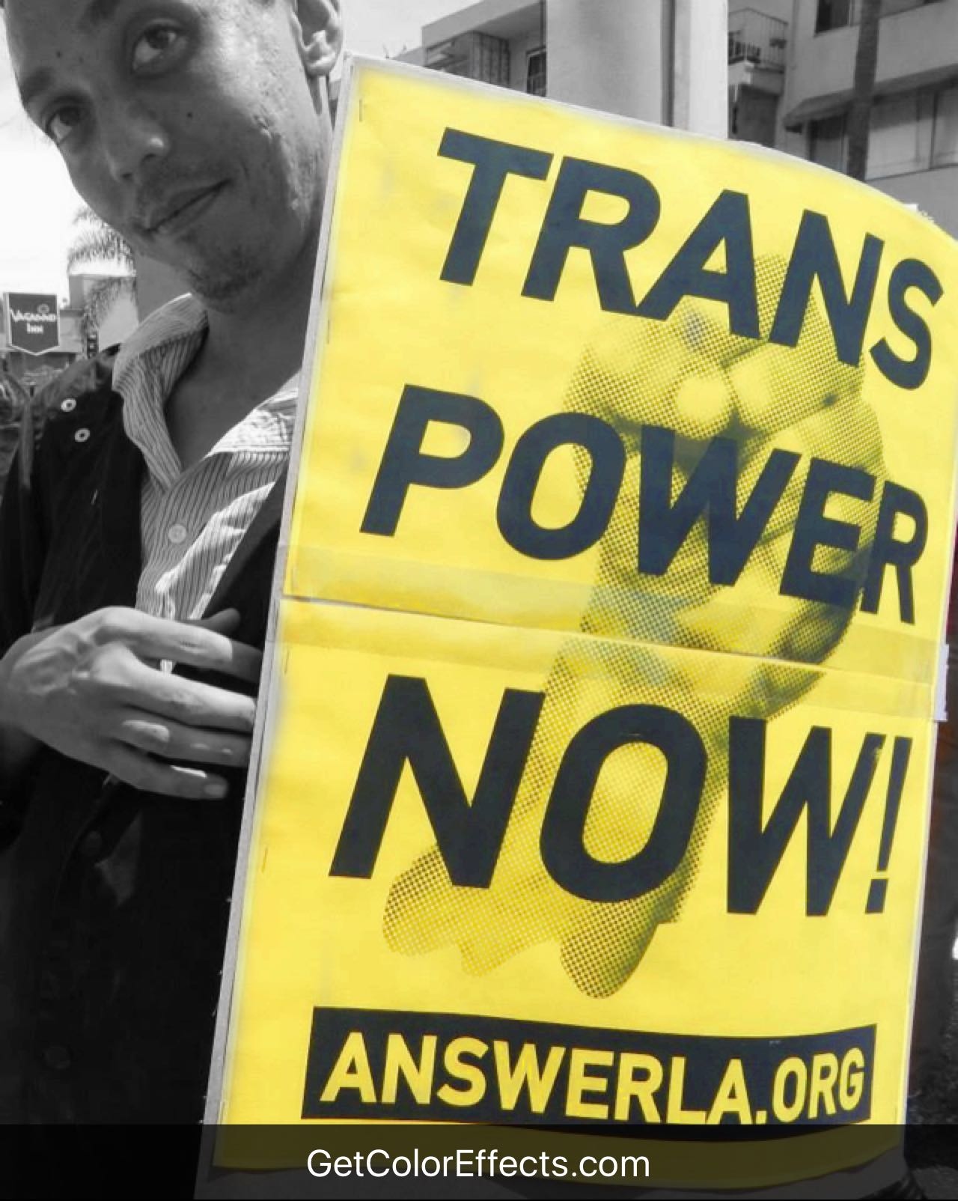

Highlighted issue: This image is supposed to highlight the struggle of the transgender community. This image was taken at an LA protest.

Example by Claudia Serrano

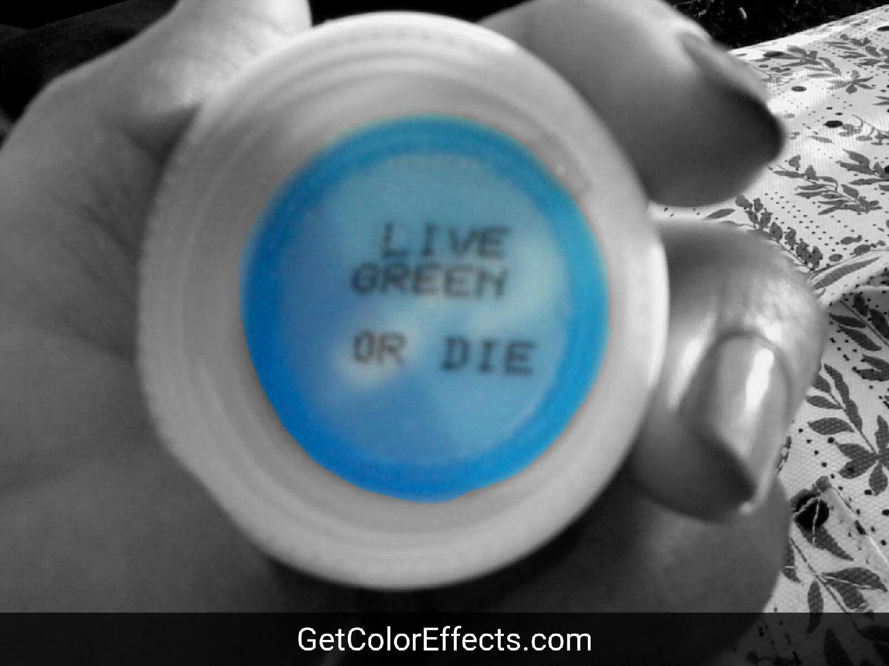

Highlighted issue: This image is supposed to highlight the daily consumption of people and how our excess and waste harms the earth on a daily basis.

